Week-4
Experiment-4: Configure different N/w topologies using Packet tracer
1. Open Cisco Packet Tracer and select the devices as per the following topologies.
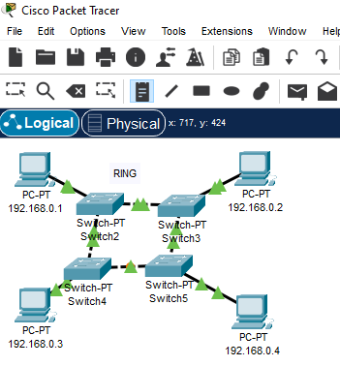

RING TOPOLOGY
S.No Device Quantity
------ ---------- ------------
1. PC 4
2. Switch 4

BUS TOPOLOGY
S.No Device Quantity
------ ---------- ------------
1. PC 3
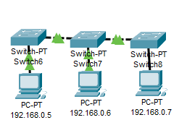
2. Switch 3

STAR TOPOLOGY
S.No Device Quantity
------ ---------- ------------
1. PC 3 OR 4
2. Switch 1
MESH TOPOLOGY
S.No Device Quantity
------ ---------- ------------
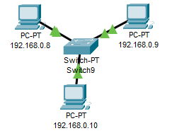
1. PC 4
2. Switch 4
MESH TOPOLOGY
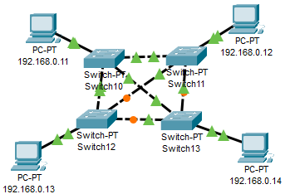

HYBRID TOPOLOGY
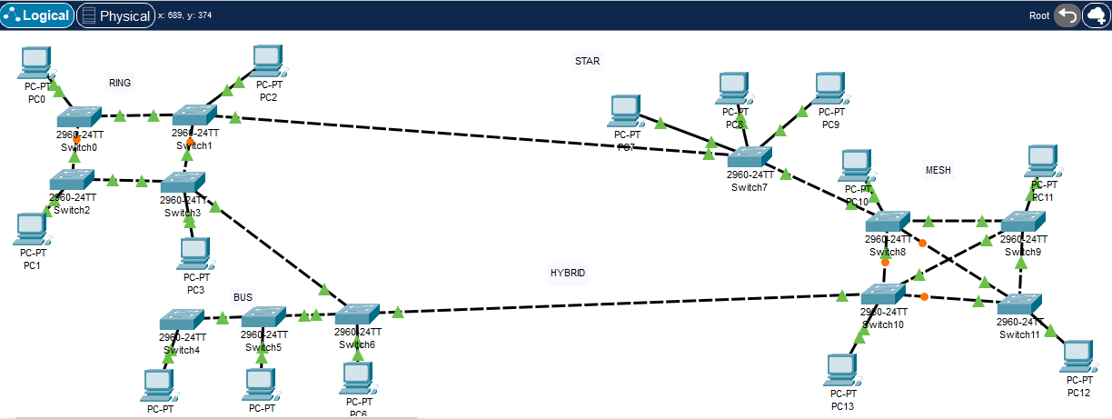

2. Configure all the IP Addresses of PC’s
3. OUTPT: PING FROM 192.168.0.1 TO 192.168.0.14
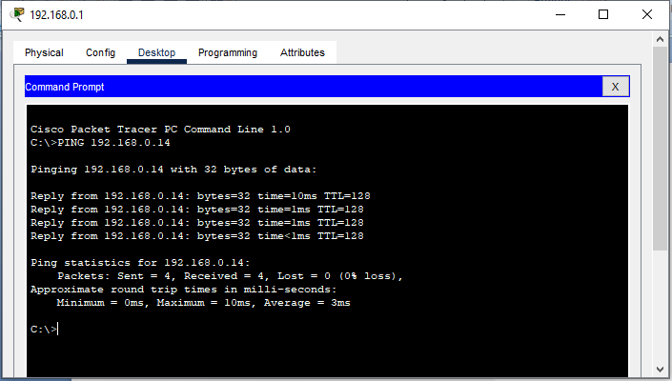

4. Similarly get the output from every PC to other PC in the N/w

1. What is Switch?

2. Define topology

3. Define the following w. r. t Topology
Ring:

Star:

Bus:

Mesh:

Hybrid:

